**MSQL DB Monitoring**

Link => <https://github.dxc.com/pages/Innovation-Automation/dynatrace_documentation/user_guides/monitoring/database_monitoring/MSSQL/MSSQL%20DB%20Deployment/>

1. Search for extenions

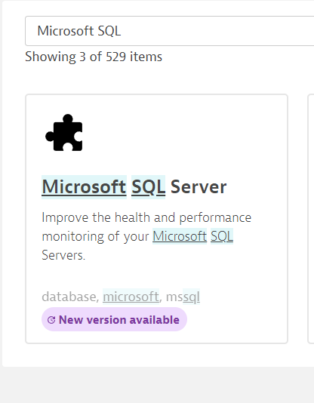

Add this to your monitoring configuration